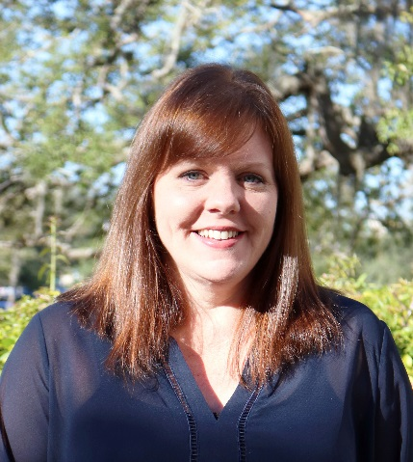
VISITING SCHOLAR
Jenifer Jasinski Schneider, Ph.D.
Associate Professor of Literacy Studies
Department of Teaching and Learning
College of Education, USF Tampa
jschneid@usf.edu

Dr. Schneider's research focuses on arts-based approaches to literacy education in which aspects of process drama and children's literature support children's symbolic development and meaning-making strategies. She also examines the ways in which digital tools affect literate practices.

Through community-engaged projects, and working within designed field experiments, Dr. Schneider's research addresses the changing set of strategies that children use to compose and communicate through print-based and multimodal texts. Dr. Schneider is the Director of the USF CLICK Conference (Children's Literature Collection of Know-how), an annual literature conference for children, the Coordinator of the doctoral program in Literacy Studies, and the faculty mentor for the Children's and Young Adult Literature Graduate Student Organization at USF.

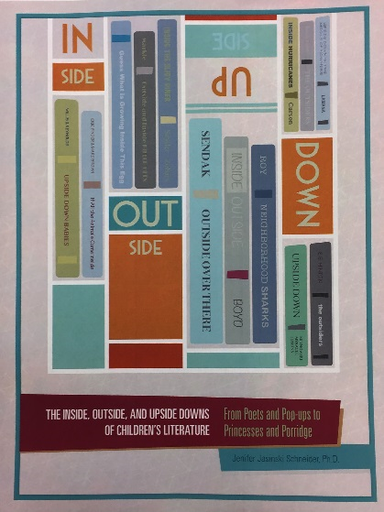
As a 2016 Fulbright Scholar in Ireland, Dr. Schneider's research included the study of Irish children's literature and reading programs, an exploration of family literacy initiatives across different Irish community contexts, and the examination of adult further education and digital literacy training models at the Waterford Institute of Technology.

Dr. Schneider's recent publications include the first USF-developed open-access etextbook, The Inside, Outside, and Upside Downs of Children's Literature (USF Scholar Commons), an edited book Casework in K-6 Writing Instruction: Connecting Composing Strategies, Digital Literacies, and Disciplinary Content to the Common Core (2014, Peter Lang) and articles in peer-refereed journals such as the Journal of Adolescent and Adult Literacy, Action in Teacher Education and The Reading Teacher.

CPS Event on Tuesday, April 4, 2017, at 7 p.m. in Fox Hall:
Family and Community: Literacy Lessons from Ireland

Proposal submitted by Anne Anderson, PEL Director of Blended and Online Learning, and sponsored by PEL and ASPEC. Contact Anne at campus extension 8884 or by emailing her at andersaw@eckerd.edu for further information or to schedule an afternoon visit with Dr. Schneider.

