Anne W. Anderson  Dissertation Proposal Prospectus  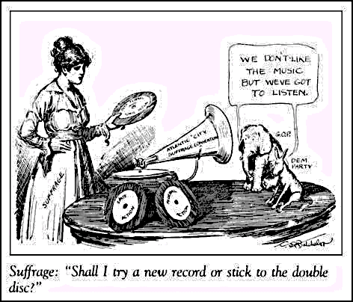  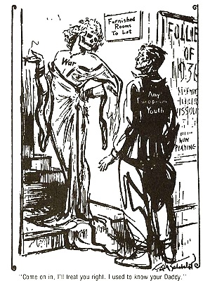  August 13, 2013  http://www.spartacus.schoolnet.co.uk/USACbatchelor.htm | 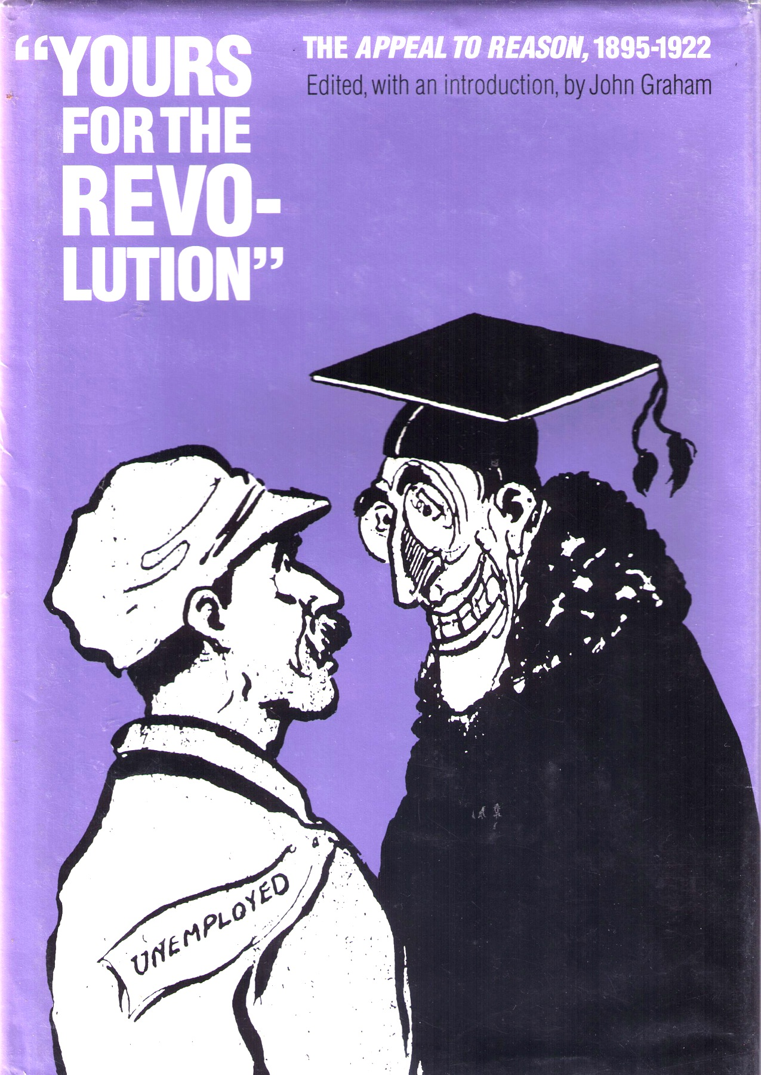

Editorial Cartoons in Two Early-Twentieth-Century Newspapers as Mentor Texts for a Young Walter Elias Disney: An Ethnographic Content Analysis

Rationale
Within a few short decades, Walter Elias Disney (December 5, 1901 – December 15, 1966) effectively exchanged the originating cultures and thematic ideologies found in a plethora of both centuries-old traditional European folk and fairy tales and modern classics, such as J. M. Barrie’s Peter Pan and P. L. Travers’ Mary Poppins, for his own Midwestern American culture and ideology. Zipes (2002) noted:
Very few critics have remarked on the fact that the ‘German’ fairy tales became fully ‘contaminated’ by American artists and writers during the 1930s, especially in the Disney studios. The features of Snow White and her Prince Charming represent the all-American ‘healthy’ ideals of beauty, prefiguring the Barbie and Ken dolls by a good twenty-five years, and the language and jokes in the film are clearly tied to American idioms and customs. Disney’s success in creating his Snow White depended on his deep understanding of the dreams and aspirations of Middle America during the 1930s and how American received fairy tales. (p. 84)

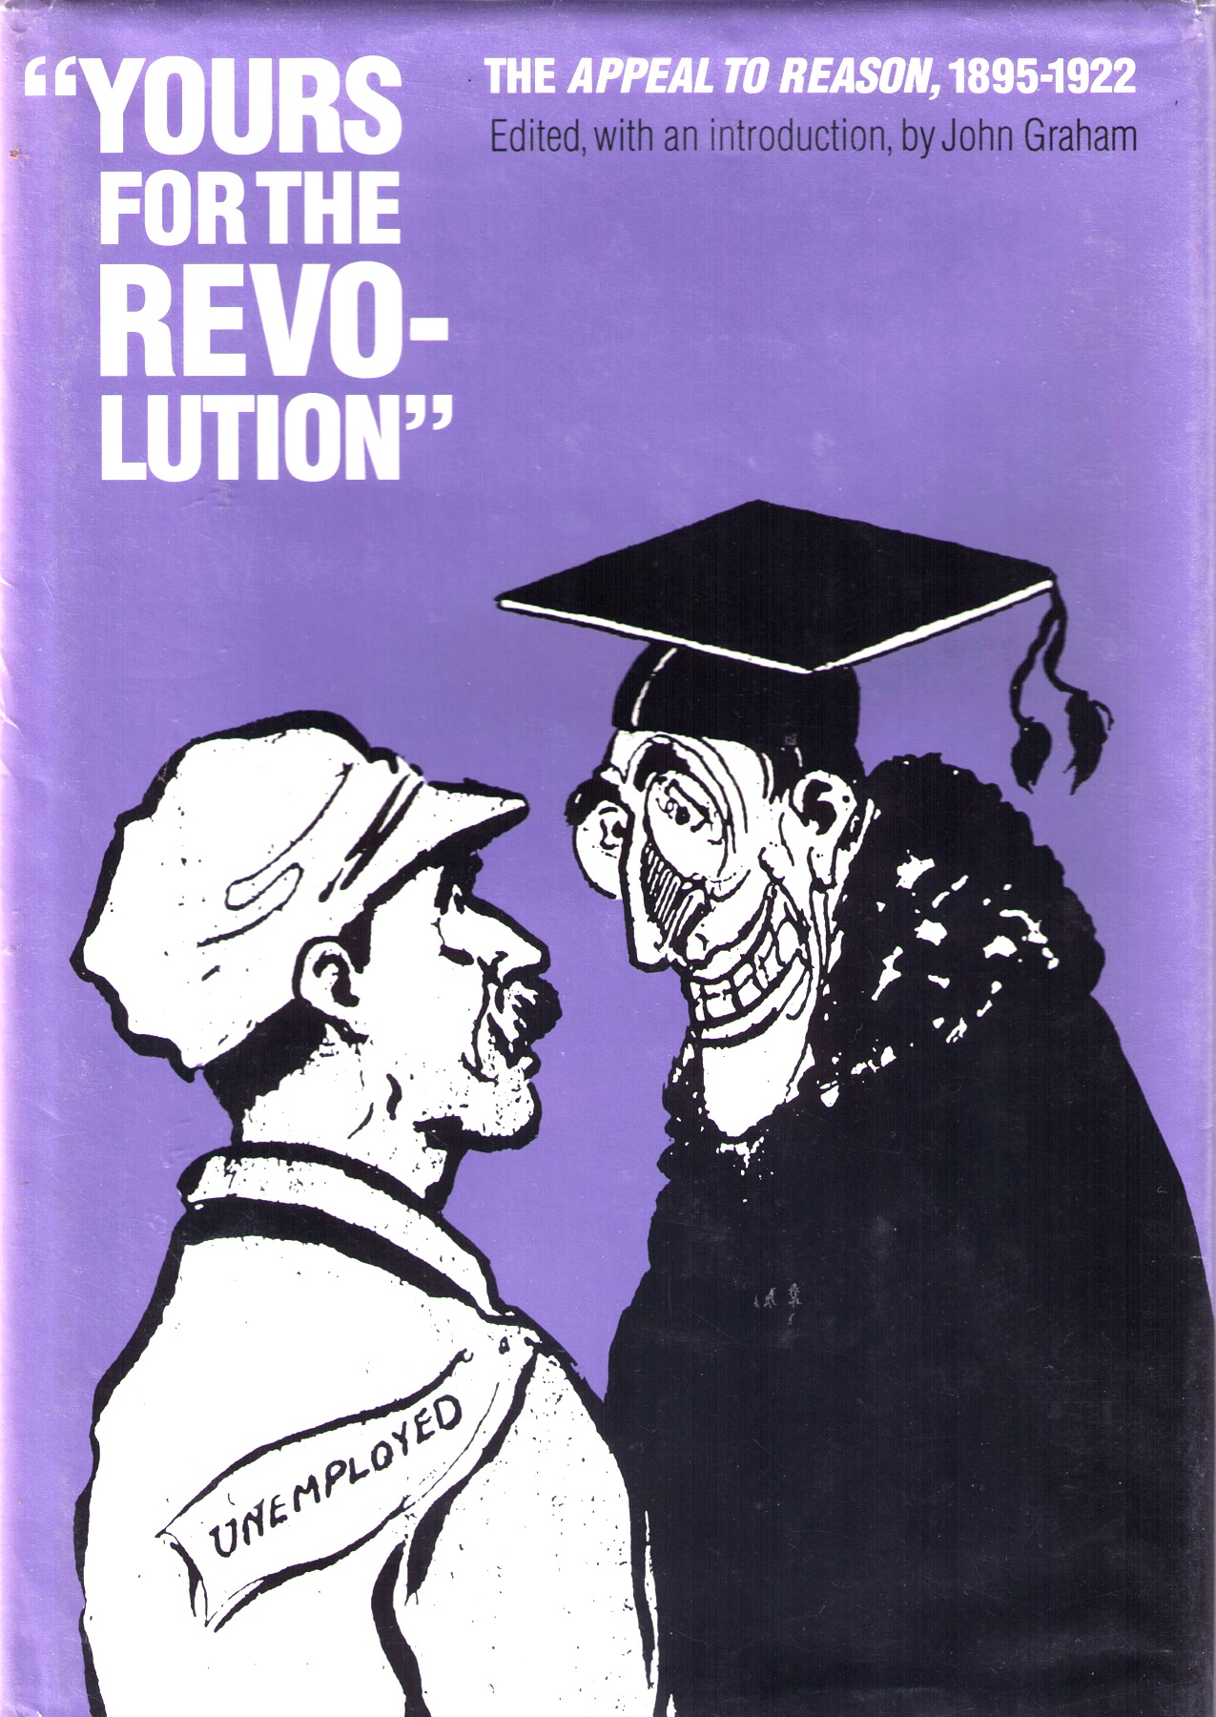
Where did this “deep understanding” come from? By most biographical accounts, Disney was neither a stellar student nor an avid reader. However, during the time the Disneys lived in Kansas City, Missouri (1911-1917), when young Walt was between the ages of ten and sixteen, his father subscribed to Appeal to Reason (Hammontree, 1969, p. 97), a Socialist weekly newspaper that sometimes printed more than 4,000,000 copies per issue (Graham, 1990). Disney also was a newsboy for the Kansas City Morning Times, the Kansas City Evening Star, and the Sunday Star during the same period (Gabler, 2006).

According to Gabler (2006), Disney “took his father’s Appeal to Reason and practiced redrawing the front-page cartoons of capital and labor until ‘I had them all down pat’” (p. 29) and he observed the cartoonists working at the Kansas City Star (p. 30).
How would this study impact the fields of literacy studies and education? Multiple generations of Americans have become progressively more familiar with a vast body of literature, not through the original literature itself but through the films of Walt Disney and his successors. Moreover, after releasing the movie versions of such traditional literature, literary fairy tales, and fantasies as The Three Pigs, Pinocchio, and Winnie the Pooh, Disney Studios then published books that used text and illustrations from the film, further establishing these versions as the “correct” ones.
Figure 1. (Above) The complete 1914 cartoon from which these two figures are pulled identifies the figure on the right as President Woodrow Wilson who had made a "let them eat cake" sort of comment in reference to the unemployed. Ryan Walker created most, if not all, of Appeal’s cartoons over the years. (Cover, lower left) This 1916 cartoon is by Kansas City Star cartoonist C. D. Batchelor, who worked for the KCS from 1911 to no later than 1914. (Cover, upper left) In 1937, Batchelor won a Pulitzer for this cartoon.

That these films, subsequent films, and the theme parks and other resulting industries continue to resonate within our culture suggests they still speak to many people’s dreams and aspirations today. Understanding the philosophies and ideologies implicit within Disney’s versions of the body of literature can help us understand the people—children and adults—who populate our schools and can help shape the curricula we devise.
Stephens (1992), in Language and Ideology in Children's Fiction, suggested "...if we consider the ideology of texts to be important then education systems in the English-speaking world often inculcate a defective model of reading" (p. 4). Do we just teach compre-hension: How did Tom Sawyer get out of painting the fence? Or do we also teach children how to consider the ideologies implicit in the texts (print, film, song lyrics, illustrations, etc.), e.g., What does Twain say in this passage about the idea of work?

Literature
There is no lack of literature about Disney and the industries he spawned. Much has been written about:
- The princess phenomenon among little girls,
- Depictions of gender, racial, and class stereotypes in his films,
- Organizational structure of Walt Disney enterprises,
- Socio-cultural studies of Disney’s theme parks, and
- Biographies of Walt Disney and others associated with Walt Disney Studios.

However, very little has been written, as Zipes noted, about (1) the ideologies contained within the Disney versions of the stories or (2) the possible sources of such ideologies.

Most biographies about Disney cover the family’s heritage, Disney’s birth, early years, and adolescence in one chapter and cover in a second chapter Disney’s young adult years up to the creation of the Steamboat Willie character in 1928. Susanin (2011) devotes an entire book to the years 1919-1928.

In this grounded theory approach, I look back further to texts present in Disney’s boyhood home that may have influenced the formation of such ideologies. Glaser “advises researchers who plan to use the grounded theory approach not to conduct a review of the literature beforehand because they are likely to be exposed to other researchers’ theories (as cited in Gall, Gall, & Borg, 2007, p. 97). My preliminary literature review covers the topics listed above. I will conduct a second literature review after the data has been collected and the latent analysis has been completed, depending on what I discover.

Research Questions
- What ideologies can be identified from examining the written and visual texts of the editorial cartoons published in Appeal to Reason between 1911 and 1917 (inclusive)?
- What artistic elements can be identified from examining the written and visual texts of the editorial cartoons published in Appeal to Reason between 1911 and 1917 (inclusive)?
- What ideologies can be identified from examining the written and visual texts of the editorial cartoons found in a sample drawn from papers published by the Kansas City Star between 1911 and 1917 (inclusive)?
- What artistic elements can be identified from examining the written and visual texts of the editorial cartoons found in in a sample drawn from papers published by the Kansas City Star between 1911 and 1917 (inclusive)?

Methods
Ethnographic Content Analysis: Altheide (1987/1996) developed ethnographic content analysis (ECA), a twelve-step method, based in grounded theory, which he used to analyze news coverage. In particular, Altheide applied this method to examining broadcast news segments of the 1979-1981 Iran hostage crisis. Since then, ECA has been used to examine such print media as two centuries’ worth of anti-gambling documents (Bernhard, Futrell, & Harper, 2010), contents of bridal books (Besel, et al., 2006), children’s picture books (Sandefur, 2004), and 19th century American and Chinese periodicals (Zeng, 2011). With Matt Blankenship (2012), I used ECA to analyze a collection of short stories.

Steps | Description
1-3 | Pursue a specific problem to be investigated. Become familiar with the process and context of the information source. Explore possible sources of information. Note the format of several (6 to 10) examples of relevant documents. Select a unit of analysis, which may change. Throughout the process, record field observations and reflections.
4-6 | List several items or categories (variables) to guide data collection and draft a protocol (data collection sheet). Test the protocol by collecting data from several documents. Revise the protocol; repeat.
7-9 | Arrive at a sampling rationale and strategy (e.g. theoretical, purposive, opportunistic, cluster or stratified). Collect the data using preset categories (if appropriate) and many descriptive examples. Apply a midpoint analysis, then complete the data collection and manifest analysis.
10-12 | Perform latent content analysis. Compare and contrast the latent content analysis results shown in the “Analysis” column, identify discourses within the latent content, and write summaries of key findings. Integrate the findings (i.e. the latent content analysis results) including the discourse interpretations in a draft document.

Hermeneutic Principles of Interpretation: Drawing on the work of Pokorn (2011), Ricouer (1976), and Spinelli (1995), I will develop a method for applying rules of interpretation to these texts.

References
Altheide, D. & Schneider, C. J. (2013). Qualitative media analysis, (2nd ed.). Los Angeles, CA: Sage.

Anderson, A. W., & Blankenship, M. U. (2012). Child perspective or adult retrospective on school: An ethnographic content analysis of how award-winning children’s authors depict teachers and principals. (Unpublished paper). University of South Florida, Tampa.

Bernhard, B. J., & Futrell, R. (2010). “Shots from the Pulpit”: An ethnographic content analysis of United States anti-gambling social movement documents. UNLV Gaming Research & Review Journal, 14(2), 15-32.

Besel, A., Zimmerman, T. S., Fruhauf, C. A., Pepin, J., & Banning, J. H. (2009). Here comes the bride: An ethnographic content analysis of bridal books. Journal of Feminist Family Therapy, 21(2), 98-124.

Gabler, N. (2007). Walt Disney: The triumph of the American imagination. New York, NY: Vintage.

Gall, M. D., Gall, J. P, & Borg, W. R. (2007). Educational research: An introduction, (8th ed.). Boston, MA: Pearson.

Graham, J., Ed. (1990). “Yours for the revolution:” The Appeal to Reason, 1895-1922. Lincoln, NE: University of Nebraska Press.

Hammontree, M. (1997). Childhood of famous Americans: Walt Disney: Young movie maker.

Pokorn, P. (2011). Hermeneutics as a theory of understanding. (A. Bryson-Gustová, Trans.). Grand Rapids, MI: William B. Eerdmans Publishing Company. (Original work published 2005)

Ricouer, P. (1976). Interpretation theory: Discourse and the surplus of meaning. Fort Worth, TX: Texas Christian University Press.

Sandefur, S. J., & Moore, L. (2004). The “nuts and dolts” of teacher images in children’s picture storybooks: A content analysis. Education, 125(1), 41-55.

Spinelli, E. (1995). The interpreted world: An introduction to phenomenological psychology. London, U.K.: Sage. (Originally published in 1989)

Stephens, J. (1992). Language and Ideology in Children’s Fiction. New York: Longman.

Susanin, T. S. (2011). Walt before Mickey: Disney’s early years, 1919-1928. Jackson, MS: University Press of Mississippi.

Zeng, Y. (2011). Image, text and imagination: Dianshizhai Pictorial and Harper’s Weekly in late 19th century media. (Doctoral dissertation). Retrieved from ProQuest LLC. (UMI Number: 3481926)

Zipes, J. (2002). Sticks and stones: The troublesome success of children’s literature from Slovenly Peter to Harry Potter. New York, NY: Routledge.

Timetable
Proposed Calendar of Due Dates for Anne Anderson
Completion Date* |  | Project / Meeting | Notes / Concerns
2013 | July 19 | Order Study Texts | Some have arrived; I’m working on others.
 | August 13, 10 a.m. | Committee Meeting | Discuss dissertation ideas; set goals and timeline.
 | September 13 | Proposal to MP | Complete literature reviews, preliminary study, and first three chapters.
 | September 25-29 Florida Reading Association Conference.
 | September 27 | Proposal to Committee
 | October 17 or 18  (Thursday) | Document to Marilyn | This is one day less than three weeks from September 27 – Deadline is October 25
 | October 31 or November 1  (Thursday) | Defend Proposal | Deadline is November 15
 | November 8-10 South Atlantic Modern Language Association Conference
 | November 28-29 Thanksgiving Holiday
 | December 4-7 Literacy Research Association Conference
2014 | January 31 | Draft to MP
 | February 7 | Grad App Deadline
 | February 14 | Draft to Committee
 | March 10-15, 2014 USF Spring Break
 | March 7 | Defend Dissertation
 | April 4 | Last Day to Defend
 | April 3-7 American Educational Research Association Conference
 | April 11 | Dissertation to GS | Deadline
 | May 2 | Final Day SPR Term
 | May 3 | Graduation
 | May 9-12 International Reading Association Conference
 | June 19-21 Children’s Literature Association Conference
 | June 22-26 DMI National Finals / Convention

