Editorial Cartoons in Two Early-Twentieth-Century Newspapers as Mentor Texts for a Young Walter Elias Disney: An Ethnographic Content Analysis
A Review of the Term “Mentor Text” as Found in the Academic and Professional Literature

“Mentor text” currently is a commonly used term in literacy education that refers to using texts of many kinds as models to teach writing. Since 2007, when Dorfman and Cappelli’s Mentor Texts: Teaching Writing Through Children's Literature, K-6 was issued, 22 trade books whose titles include the phrase “mentor texts” have been published (Table 1). The concept, however, is not new. The used most often across all forms of literature (Figure 1), although not without some ambiguity, is “model text” with “model” being used both in the sense of ideal source and in the sense of source of ideas. Metaphorically, the word “model” connotes a more passive stance than either “touchstone” or “mentor,” as even a living model typically is observed without direct interaction as in an art studio or on a fashion runway.
Within the last half-century, the term “touchstone text” also has been used in the field of education, primarily to refer to texts that a reader returned to again and again for various purposes (CITE). Only one trade book, with an accompanying student book, has been published with this phrase in the title, although “touchstone” (singular or plural) by itself appears in a number of titles, not all about teaching reading or writing. It should be noted that the understanding of “touchstone” has changed since Matthew Arnold introduced it into the field of literary criticism in an 1880 essay in which he advocated the use of “lines and expressions of great masters [of poetry], and to apply them as a touchstone to other poetry” (as cited in Cuddon, 1999, p. 923). Arnold, however, had a more concrete metaphor in mind as most people of that day would have understood a touchstone as a piece of hard, dark, fine-grained stone such as slate that was used to determine the quality of softer metals such as gold and silver, which would leave a mark when rubbed against the touchstone. One might think the works of the great masters would be the precious metals themselves, but Arnold’s idea caught on—perhaps the hard touchstone was intended to connote durability—and trickled down into the modern education world, where it became imbued with almost mystical meaning in the sense that a touchstone text was portrayed as drawing a reader to itself by the force of its powerfully arranged words.
“Mentor text” carries a slightly different connotation, although one no less fraught with metaphorical mistaken identity. According to the Oxford English Dictionary, the word “mentor” has no particular derivation other than being the name of the somewhat elderly friend of Odysseus charged with watching over his son, Telemachus, and his estate while Odysseus went off to fight in the Trojan War. While it is unclear whether and how Mentor fulfilled this charge, it was not he but Athena in the guise of Mentor who advised Telemachus to go and search for his father after the war. A similar ambiguity surrounds the uses of the word today, which in its modern form dates to a 1699 French adaptation of Telemachus’s story (Mothe-Fénelon). As Roberts (2000) noted in his phenomenological study of the literature about mentoring, “Definitions of mentoring are elusive” (p. 148). Additionally, Roberts discovered, “mentor,” used both as verb and as noun, refers variously to a person, to a relationship, to a process, and to the activities that take place within the process all of which often involves shades of meaning that include, among others, ideas of supervising, teaching, coaching, and helping.

One Trade Book Author’s Usage and Understanding of “Mentor Text”

My review of the phrase “mentor text,” as found in academic literature related to reading and writing, suggests current usage and understanding of the term is equally malleable. For example, consider these passages in Kelley Gallagher’s (2011) Write Like This: Teaching Real-World Writing through Modeling and Mentor Texts. Gallagher described the purpose of his book thus:
To answer these questions [of how to help students see the importance of writing well], we must give careful consideration to the two premises that center this book: (1) If we are to build students who grow up to write in the real world, we must move our writing instruction beyond a “cover the state standards” mind-set by introducing our young writers to additional real-world discourses, and (2) In reaching our students how to write, we must provide them with authentic modeling—modeling that comes from both the teacher and from real-world texts. As the teacher in the room, each of us must become a mentor. As such, we must stand next to our students and show them how real writers write. And in addition to standing next to us, our students should also stand next to and study other expert writers. I want my students to ask themselves, “What did these writers do that I’d like to try?” (p. 8)
In the paragraph above, Gallagher identified each teacher as “a mentor” and used active verbs to describe what the teacher/mentor does: introduce real-world discourses, provide authentic modeling, stand next to students and show students how real writers write. In the last two sentences, the student becomes the active agent, standing next to and studying “other expert writers” and asking themselves reflective questions. “Other expert writers” also appear as passive, if ephemeral, agents next to whom the students stand. The texts, described as “real-world discourses” and “real-world texts,” are depicted, on the one hand, as passive elements but, on the other hand, as conduits through which the students will understand “other expert writers” and, although Gallagher does not explicitly state this, the writing choices those expert writers made.
Gallagher then spent six pages (pp. 9-14) reflecting on writing, describing what he identifies as eight purposes of real-world writing and modeling, through sections of scripted dialogue, how he helps students take any topic and write about it with different purposes in mind. Gallagher followed this section with another four pages (pp. 15-18) describing the modeling process in depth. Next, Gallagher included a full-page example of a student’s writing on a particular topic but writing with different purposes (to inform, to reflect on, to persuade, etc.) each time (p. 19)—in essence a mentor text, although not labeled or identified as such, that shows teachers what the outcome of Gallagher’s modeling and the student’s writing looks like.
Next, Gallagher devoted the following two-paragraph section to describing mentor texts—and this is the only place in the book where Gallagher discusses what mentor texts are:
Beyond teacher modeling in the classroom, my students benefit immensely from closely examining writing from the real world. If I want my students to write editorials, it helps to show them some strong editorials. If I want my students to write reviews from Amazon.com, we spend some time looking at some previously posted Amazon reviews. Yes, it is important to show students how the teacher writes, but it is also of paramount importance to provide students with mentor texts so they can see how other writers compose. It is critical that my students be able to move beyond simply telling me what a text says; I want them to begin to recognize how the text is constructed. I certainly want them to stand next to me while I write, but I also want them to stand next to Anna Quindlen, or Rick Reilly, or Leanard Pitts and notice what they do when they write. I want them to see how they write. Earlier, I mentioned that my writing instruction is modeled after an “I go, then they go” rhythm. In addition, I want my students to follow a “Rick Reilly goes, then they go” approach. This is why, in addition to the modeling I have done in front of my students, you will find mentor texts from real-world writers—templates, if you will—throughout this book.

So there you have it, the formula that underscores this book: Teach your students real-world writing purposes, add a teacher who models his or her struggles with the writing process, throw in lots of real-world mentor texts for students to emulate, and give our kids the time necessary to enable them to stretch as writers. (pp. 20-21)
In this passage, the teacher again is the primary active agent who shows, provides, models-writes, teaches, and gives. Collaboratively, teachers and students “spend some time looking at” texts and stand next to each other, figuratively and/or literally, and to the implied apparitions of presumably expert writers, this time named writers. While Gallagher assigned what sound like active verbs to students, he positioned the students as either passive or willing recipients of his objects and desires: students benefit from what Gallagher, the mentor/teacher, provides; students look at what he wants them to write; students stand next to designated people; students see what he sees, follow where he goes, and become what he thinks they ought.
Gallagher defined “mentor text” itself as “from the real world,” as “strong,” and as “templates” but also, in the case of the Amazon.com reviews, just as “previously posted,” suggesting that any text can be a mentor regardless of quality. Perhaps Gallagher intended the reader understand that we can learn from bad examples, too, but the gist of the passage suggests not. As in the passage on page 8, Gallagher implied in this passage that the text itself will reveal the writer’s process of composition to the student, not just the end product the writer created. Somehow, by studying the text, the student will “notice what they [the expert writers] do when they write” and will “see how they [the expert writers] write” (p. 20). In fact, Gallagher suggested that students will “emulate” real-world mentor texts…if teachers just throw enough of them at them.
Gallagher included many examples of texts he has used in lessons, but he seldom, if ever, had students explore the text on their own. For example, Gallagher played a popular song, which introduces the idea of making a mistake. Next, he gave students a copy of an essay about a mistake the author made, which they read. Then Gallagher asked “some surface-level questions: What is the writer’s mistake? What details does she recall leading up to the mistake? Looking back at the event, what are the writer’s thoughts today?” (p. 29). After this discussion, Gallagher directed students to “revisit and color code the text” to show the difference between telling about an experience and reflecting upon the experience. Then students began developing their own essays, using a graphic organizer provided by Gallagher “to help them remember that the author in the mentor text” used both expression and reflection (p. 30). Gallagher modeled filling out the organizer and drafting an essay based on the organizer; the students followed his lead.
Perhaps most telling of Gallagher’s thoughts in assigning the role of mentor is this passage in which he describes modeling the drafting of an essay:
As I create a first draft, I think aloud as I consider each word and as I write each sentence. The teacher is the best writer in the room (that’s you [presuming an audience of teachers reading the book] and me); therefore it is critical that the best writer in the room models the confusion, the messiness, the stopping and starting, the hesitation that comes with trying to compose. (p. 33)
Notice that the “best writer in the room” is not the author of the mentor text or the mentor text itself. The best writer, according to Gallagher, is the teacher. Who, then, is the mentor?
My explication of Gallagher’s text is not intended to disparage Gallagher’s work or his methods—Gallagher, by all accounts, is an effective teacher and a strong writer. My intent is to show the ambiguity surrounding the term “mentor text.” What Gallagher does not state, but which he implies throughout these passages, is that the teacher is the mentor who guides the students—either through docent-like instruction or through the more subtle and more collaborative process of flint-striking to produce the spark of recognition/cognition—to an understanding of what makes a particular text effectively achieve its purpose, which is to communicate a particular idea to a particular audience.
But are there other understandings of what mentor texts are and of how they influence people? What kinds of texts are considered mentor texts and what aspects of the texts are being taught/caught and by whom and how? Because I argue in this dissertation that particular editorial cartoons may have served as mentor texts for a young Walt Disney—outside of a classroom led by a teacher—it is important to consider other current academic literature about mentor texts.

Defining and Describing the Field
I began by using a multiple-database search tool for the phrase “mentor text,” both with and without enclosing quotation marks. I searched for literature published between 2007 and 2014, partly because the beginning date coincided with the publication of the first trade book including the phrase “mentor text” in the title. Additionally, I considered that work published in 2007 appeared three years after the American Diploma Project’s 2004 report, Ready or Not: Creating a High School Diploma That Counts, which presaged the development of the Common Core State Standards. Work published in 2007 or later would be more apt to have been researched and written after the ADP’s 2004 report and thus would be more likely than articles published prior to 2007 to address the most current practical usages of the terms. I included only English-language, peer-reviewed articles; after eliminating duplicates and articles that only contained the word “mentor” and the word “text” but in passages unrelated to each other, I was left with 65 articles.
Limiting the source material to academic journals excluded material that might prove helpful in a larger study of how the term “mentor text” is understood. For instance, none of the material was written by a child or youth, none was written from the perspective of a non-professional parent, and none was written by a member of the general public for the general public, e.g., a newspaper reporter writing a news article. However, while I limited the field to academic voices writing for academic audiences, the search yielded articles diverse in other respects, including, as Ogawa and Malen (1991) suggested in their article on multi-vocal literature reviews, different types of articles (how-to, studies, and reflective essays) on a variety of topics (teaching various types and traits of writing, teaching reading, teaching social justice, etc.), and by people in a a variety of professions (university professors, classroom teachers, librarians, religious clerics, etc.) from various countries. More than 30 journals were represented with almost a third of the articles appearing in the Journal of Children’s Literature (11), Reading Teacher (9), Journal of Adolescent and Adult Literacy (5), and the New England Reading Association Journal (4). Journals outside the field of current education concerns included English Literature in Transition, 1890-1920 (1), History of European Ideas (1), and Journal of the American Oriental Society (1). In terms of authorship, almost no articles were written by the same author or authors. Exceptions were Kelly Gallagher, author of one of the textbooks and one of the articles, and Louise Wrobleski, first author of two articles, suggesting perhaps a lack of depth of study in the area of mentor texts.

Constructions of “Mentor Text”
Most of the authors constructed mentor texts, in one way or another, as pedagogical tools to be used by teachers. Jiménez and McIlhagga (2013) for instance, suggested that, in addition to being aware of Rosenblatt’s (1994/1978) aesthetic-efferent continuum, teachers need to be aware of a personal-pedagogical continuum, i.e., the differences between responding to literature in personal ways versus thinking about how the literature can be used to teach something. In their article, Jiménez and McIlhagga used the term “mentor text” only one time, as an example of an item at the far end of the pedagogical tool side of the personal-pedagogical continuum (p. 53). Similarly, rather than being seen as sites of potential discovery, Suen and Duke’s (2013) trade book, Teaching STEM and Common Core with Mentor Texts: Collaborative Lesson Plans, presented mentor texts as only those texts that addressed particular questions and provided corresponding answers to topics listed in the STEM portion of the Common Core State Standards.

Best article only mentioned “mentor text” one time, as a pedagogical tool – Jiménez & McIlhagga

Mentor texts and concerns about plagiarism (writing thief!)

Intertextuality

Visuals and graphics
References

Austin, P. (2008). Inspired by...: The art of sharing children's literature to ignite the creative process. Journal of Children's Literature, 34(2), 51-59.

Brisk, M. E., Hodgson-Drysdale, T., & O'Connor, C. (2011/2012). A study of a collaborative instructional project informed by systemic functional linguistic theory: Report writing in elementary grades. Journal of Education, 191(1), 1-12.

Charron, N. N., Fenton, M., Harris, M., & Procek, C. (2012). Encouraging Struggling Writers K -12: Practical Ideas from Practicing Practitioners. New England Reading Association Journal, 48(1), 66-72.

Chase, M. (2008). The Warp and the Weft: Using Mentor Texts to Weave Together Reading, Science, Writing, and Art. Journal of Children's Literature, 34(2), 60-67.

DeFauw, Danielle L. (2013). 10 writing opportunities to 'teach to the test'. Reading Teacher, 66(7), 569-573. DOI:10.1002/TRTR.1161.

Dorfman, L. R., & Cappelli, R. (2007). Mentor Texts: Teaching Writing through Children’s Literature, K-6. Portland, OR: Stenhouse.

Gehsmann, K. M. & Templeton, S. (2011/2012). Stages and standards in literacy: Teaching developmentally in the age of accountability. Journal of Education, 192(1), 5-16.

Giorgis, C., Bedford, A., & Fabbi, Jennifer L. (2008). From the editors: Children's books as mentor texts. Journal of Children's Literature, 34(2), 4-7.

Halladay, J. L. & Moses, L. (2013). Using the Common Core Standards to meet the needs of diverse learners: Challenges and opportunities. New England Reading Association Journal, 49(1), 33-44.

Jiménez, L. M., McIlhagga, K. K. A. (2013). Books for young readers: Strategic selection of children's and young adult literature. A Journal of Education, 193(3), 51-57.

Matoush, M. M. (2009). Offering up “Circle unbroken: The story of a basket and its people” as touchstone text. Journal of Children's Literature, 35(1), 38-42.

Ogle, D. & Correa-Kovtun, A. (2010). Supporting English-language learners and struggling readers in content literacy with the "partner reading and content, too" routine. Reading Teacher, 63(7), 532-542.

O’Neil, K. (2010). Once upon today: Teaching for social justice with postmodern picturebooks. Children's Literature in Education, 41(1), 40-51. DOI: 10.1007/s10583-009-9097-9.

Pavlak, C. M. (2013). "It is hard fun": Scaffolded biography with English learners. Reading Teacher, 66(5), 405-414.

Pytash, K. E., Edmondson, E., & Tait, A. (2014). Using mentor texts for writing Instruction in a high school economics class. Social Studies Research & Practice, 9(1) 95-106.

Rawson, C. H. (2014). Every flower in the garden: Collaboration between school librarians and science teachers. School Libraries Worldwide, 20(1), 20-28. DOI: 10.14265.20.1.003

Rosenblatt, L. (1994/1978). The reader, the text, the poem: The transactional theory of the literary work, 2nd ed. Carbondale, IL: Southern Illinois University Press.
Skilton-Sylvester, E. (2010). An excellent mentor text for new (and not-so-new) ethnographers. Linguistics and Education, 21(4), 314-316.

Sowa, P. & Lacina, J. (2011). Preservice teachers as authors: Using children's literature as mentor texts in the United Arab Emirates. Childhood Education, 87(6), 395-401. DOI: 10.1080/00094056.2011.10523222

Strassman, B. K., MacDonald, H., & Wanko, Lindsay. (2010). Using captioned media as mentor expository texts. Reading Teacher, 64(3), 197-201. DOI: 10.1598/RT.64.3.5.

Sychterz, T. (2009). Mentor texts that inspire memoir. Journal of Children's Literature, 35(1), 32-37.

Ward, B. & Day, D. (2008). A dozen great books: Literature as mentor texts. Journal of Children's Literature, 34(2), 28-30.

Wrobleski, L. B., Cushing, D., Hemphill, K., Johnson, J., Jorgensen, J., Marcotte, M., Lurvey, A., Prewitt, K., & McMullen, K. (2011). From the ground up: Improving student writing through teacher collaboration. New England Reading Association Journal, 47(1), 28-35.

Young, C. & Rasinski, T. V. (2013). Student-produced movies as a medium for literacy development. Reading Teacher, 66(8), 670-675. DOI: 10.1002/trtr.1175.

Zarnowski, M. (2008). The craft of historical nonfiction writing: Learning from mentor texts. Journal of Children's Literature, 34(2), 43-50.

Table 1. This table lists trade books published since 2007 that included the phrase “mentor text(s)” in the title of the book. None were found published prior to 2007.
 | Title | Author(s) | Publisher | Year
1 | Mentor Texts: Teaching Writing Through Children's Literature, K-6 | L. Dorfman &  R. Cappelli | Stenhouse | 2007
2 | Using Picture Books to Teach Writing With the Traits: K-2: An Annotated Bibliography of More Than 150 Mentor Texts With Teacher-Tested Lessons | R. Culham &  R. Coutu | Scholastic | 2008
3 | Nonfiction Mentor Texts: Teaching Informational Writing Through Children's Literature, K-8 | L. Dorfman &  R. Cappelli | Stenhouse | 2009
4 | I Can Write Like That!: A Guide to Mentor Texts and Craft Studies for Writers' Workshop, K-6 | S. Ehmann &  K. Gayer | IRA* | 2009
5 | Month-by-Month Trait-Based Writing Instruction: Ready-to-Use Lessons and Strategies for Weaving Morning Messages, Read-Alouds, Mentor Texts, and More ... Writing Program | M. Walther &  K. Phillips | Scholastic | 2009
6 | Using Mentor Texts to Teach Writing With the Traits: Middle School: An Annotated Bibliography of 150 Picture Books, Chapter Books, and Young Adult Novels With Teacher-Tested Lessons | R. Culham, J. Blasingame, &  R. Coutu | Scholastic | 2010
7 | Mentor Author, Mentor Texts: Short Texts, Craft Notes, and Practical Classroom Uses | R. Fletcher | Heinemann | 2011
8 | Awakening Brilliance in the Writer's Workshop: Using Notebooks, Mentor Texts, and the Writing Process | L. Morris | Routledge | 2011
9 | Teaching Writing With Mentor Texts in the Primary Classroom: 20 Lessons Based on Favorite Picture Books That Introduce Story Structure, Nonfiction Text Features & Author's Craft | N. Groeneweg | Scholastic | 2011
10 | Write Like This Teaching Real-World Writing Through Modeling and Mentor Texts | K. Gallagher | Stenhouse | 2011
11 | Deeper Writing: Quick Writes and Mentor Texts to Illuminate New Possibilities | R. W. Holland | Corwin | 2012
12 | Poetry Mentor Texts Making Reading and Writing Connections, K-8 | L. Dorfman &  R. Cappelli | Stenhouse | 2012
13 | Fun-Size Academic Writing for Serious Learning: 101 Lessons & Mentor Texts--Narrative, Opinion/ Argument, & Informative/Explanatory, Grades 4-9 | G. S. Bernabei & J. A. Reimer | Corwin Literacy | 2013
14 | Texts and Lessons for Teaching Literature: with 65 fresh mentor texts from Dave Eggers, Nikki Giovanni, Pat Conroy, Jesus Colon, Tim O'Brien, Judith Ortiz Cofer, and many more | H. Daniels & N. Steineke | Heinemann | 2013
15 | Finding the Heart of Nonfiction: Teaching 7 Essential Craft Tools with Mentor Texts | Georgia Heard | Heinemann | 2013
16 | Teaching STEM and Common Core with Mentor Texts: Collaborative Lesson Plans, K-5 | A. Suen &  S. Duke | Libraries Unlimited | 2013
17 | Common Core Grammar Toolkit, The: Using Mentor Texts to Teach the Language Standards in Grades 3-5 | S. Ruday | Routledge | 2013
18 | Nonfiction Writing Strategies Using Content-Area Mentor Texts | M. S. Freeman | Capstone Classroom | 2014
19 | Oral Mentor Texts: A Powerful Tool for Teaching Reading, Writing, Speaking, and Listening | C. Dierking &  S. Jones | Heinemann | 2014
20 | The Writing Thief: Using Mentor Texts to Teach the Craft of Writing | R. Culham | IRA* | 2014
21 | The Common Core Grammar Toolkit: Using Mentor Texts to Teach the Language Standards in Grades 6-8 (Eye on Education Book) | S. Ruday | Routledge | 2014
22 | Grammar Matters Lessons, Tips, and Conversations Using Mentor Texts, K-6 | L. Dorfman &  D. Dougherty | Stenhouse | 2014
Source: Amazon.com (new and used books) / *International Reading Association

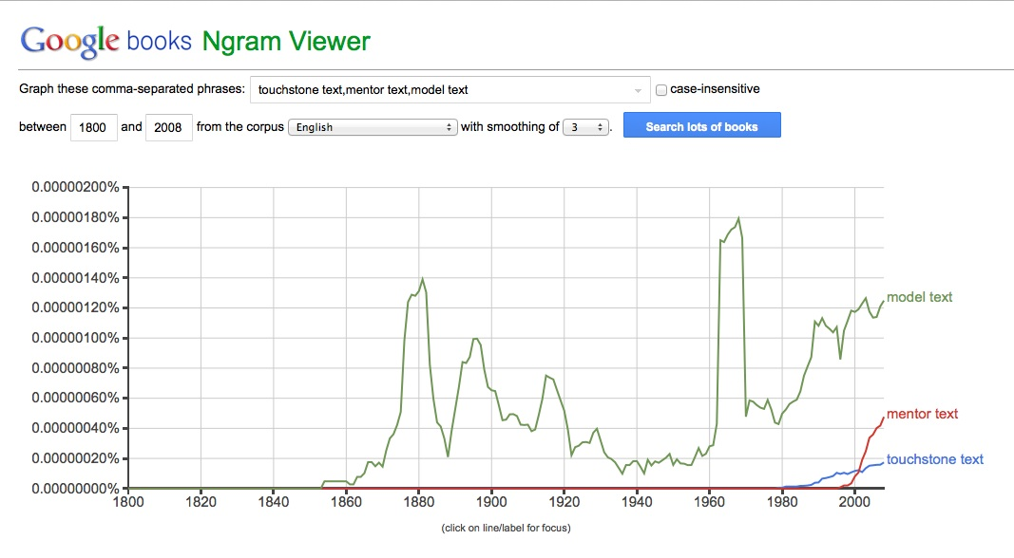
Figure 1. This Google Ngram shows the relative occurrences of the phrases "touchstone text," "mentor text," and "model text" in English-language books published between 1800 and 2008, inclusive, and contained in the Google books system. Examining some of the “model text” sources indicated that “model” sometimes was used in the sense of an ideal source and sometimes in the sense of a source of ideas.

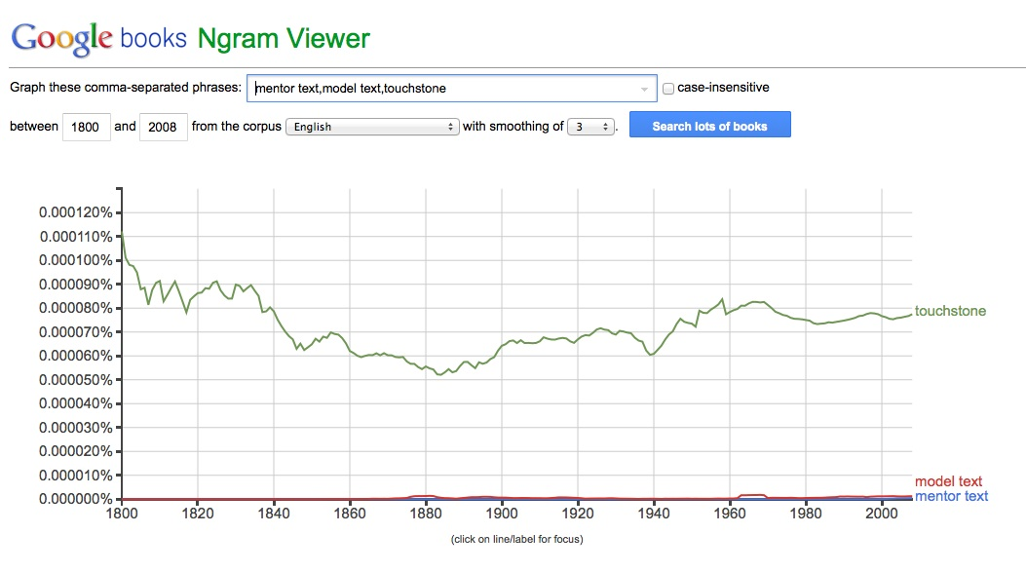
Figure 2. By contrast, this Google Ngram shows the relative occurrences of the word "touchstone" and the phrases "mentor text" and "model text" in English-language books published between 1800 and 2008, inclusive, and contained in the Google books system. The word “touchstone” originally referred to a means of assaying precious metals by rubbing them against a touchstone. Notice the discernable increase in the term “model text” around 1880, probably coinciding with Matthew Arnold’s use of the term “touchstone” to describe a model-text means of determining quality poetry.

